My First Encounter In Epic Citadel
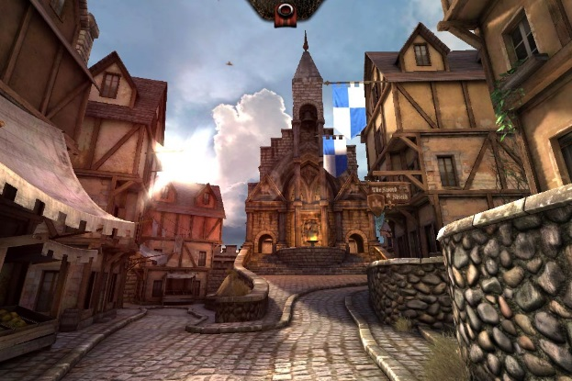
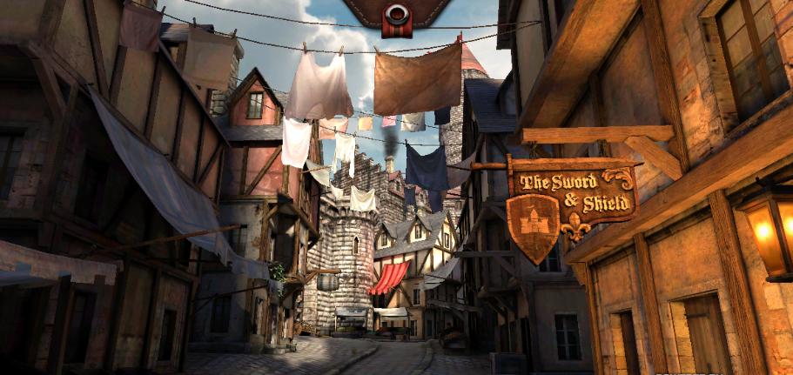
Imagine a place where everything grows, where water trickles down mountains, where all the streets are calm: there is such a place where dreams come true. Epic Citadel is waiting for you.
Stunned, I cautiously walked through the cobbled streets with the smell of beer drifting up my nose. The Sword and the Shield’s pub sign was creaking in the wind. Stalls of fruits and vegetables cluttered the streets. Church bells were echoing through my scull like a bat call in a cave. Terrified and nervous, fluttered and scared, I tentatively tip toed into the ferocious church. A huge statue had rose from the marble floor. One slip of my boot and I could break my neck in two. I fled the church: there was a ghostly feel about this town. Marooned, abandoned and scared, I lay on the cobbled streets staring at an eagle in the sky as I drifted off into a deep sleep. When I awoke, I jumped to my feet. Then I realised I was still in the creepy streets of Epic Citadel. As I turned round, I saw a mysterious passage. I was wary at first but then I went in. Finally, I found a way out of this place – well that’s what I thought.
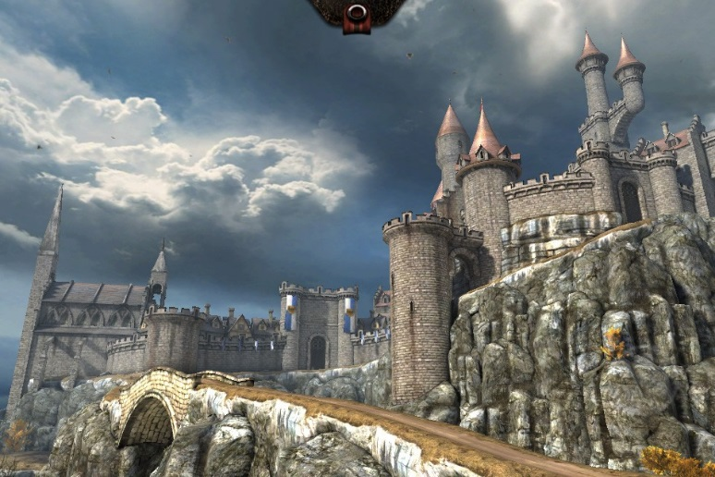
The breeze in my face and the dust in the air was nice, I could taste the salt from the river trickling under me. I raced down a dirt path. Bright and colourful tents pulling me closer to them. I peered over the side of the rock. There were recently died trees like I would be if I don’t get something to eat fast. Out of the corner of my eye, I saw a humungous castle. I stumbled back up the cliff.
As I got closer, there were blue and white velvet flags hanging over me. Beautiful courtyards surrounded the castle with an archery and gardens. I entered the castle’s kitchen. I gorged myself in posh foods. I was growing to like this place as much as home. I visited the castle three times a day’s seven days a week for the rest of my life.
S.C.

