The Piano
I felt my beloved Mia was still with me but really she was gone. Oh, how I miss my lovely Mia, but that still didn’t stop me from thinking about her. Tears of joy trickled down my pale white face as I remembered the last holiday we went on.
As I remembered all the memory’s we had together, the last one that went through my mind was when I sat next to her as she took her last breath in the hospital room and said. “I will always remember you, can you do the same.” Then she was gone. Calmly, I went on playing our favourite, prehistoric tune. Who am I going to love now? I thought.
Then with a clap of thunder, I was brought back to reality. Then as I change the tempo, it takes me back to the years in the dreaded war. During World War 2, I was a medic and I was on the second line in the troop. I wore a dirt coloured, green army suit with a shotgun strapped to my back.
Distressed, scared, worried I instructed my brother to go out and fight. Then suddenly, I heard a loud sound. “BANG!” went the bullet that struck my brother in the chest. I was terrified, I didn’t know if I had done the right thing. But anyway I rushed over to see if he was all right but I knew it wouldn’t be. I held him in my arms as he said his last words. “Take care of the family big bro.” with that he was gone.
I felt like I could have done more, no I should have done more. Then as I play a low tempo, I bring myself back. Then memory’s gently started flooding my brain- memories about Christmas 1926.
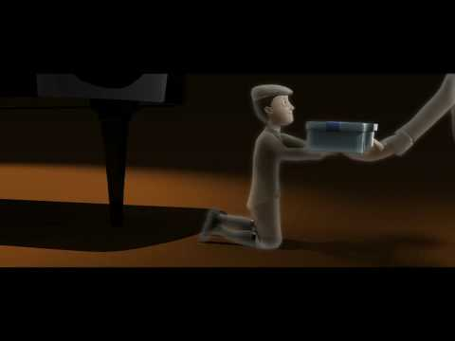
It was Christmas day and all my family were in our childhood house at Green Rose cottage. I was so excited I couldn’t stay in my bedroom so I ran downstairs. Wildly, eagerly, frantically, I jumped my last step to find all my family waiting for me in the living room.
“MERRY CHRISTMAS!” they all shouted. My aunt- that came all the way from Italy – gave me a gorgeous blue box. It was wrapped in a sea-blue ribbon and it was an immense present. As I opened the box, inside was a pleasing hobby horse.
I said thank you to aunt and then a tingle down my spine set me off around the room on it. Due to having cancer in the past, I thought it would be nice if I pass it down to my grandchild.
A chirp of a bird bought me back. As I played the solemn tune my grandchild helped me play the last note.
By ML

